A STUDY ON EFFECTIVENESS OF HR AUTOMATION PROCESS
WITH SPECIAL REFERENCE TO TALENT ACQUISITION MODULE
ACROSS IT COMPANIES

By HARIPRIYA K J
ROLL NO: 1926MBA0028
REG NO: 68319200017

A PROJECT REPORT

Submitted to the

FACULTY OF MANAGEMENT SCIENCES

in partial fulfilment for the award of the degree
of

MASTER OF BUSINESS ADMINISTRATION



CENTRE FOR DISTANCE EDUCATION ANNA UNIVERSITY
CHENNAI 600 025

MARCH, 2022

BONAFIDE CERTIFICATE

Certified that the Project report titled “A Study on Effectiveness of HR Automation Process with Special Reference to Talent Acquisition Module across IT Companies” is the bonafide work of Ms. Haripriya K J who carried out the work under my supervision. Certified further that to the best of my knowledge the work reported here in does not form part of any other project report or dissertation on the basis of which a degree or award was conferred on an earlier occasion on this or any other candidate.



Signature of Student Signature of Guide

Name : HARIPRIYA K J | Name : | Dr.R. NADANASABAI, MBA, MPhil, PhD
Roll No : 1926MBA0028 | Designation : | Associate Professor
Reg. No : 68319200017 | Address : | St.Joseph's College of Engineering, OMR Road, Chennai - 600 119.
 |  | .

CERTIFICATE OF VIVA-VOCE-EXAMINATION

This is to certify that Ms. HARIPRIYA K J (Roll No. 1926MBA0028; Register No. 68319200017) has been subjected to Viva-voce-Examination on …………………………
at …………….. at the Study Centre, College of Engineering, Chennai - 600 025.

Internal Examiner: External Examiner:

Name: Name:

Designation: Designation:

Address: Address:

Coordinator Study centre Name:
Designation: Address:

Date:

ABSTRACT

HR automation is the process of enhancing the HR department’s efficiency by automating standard and repetitive tasks by using tools/software/system implementation. Automation helps free up the HR personnel from tedious manual tasks and allows them to focus on more complex functions like decision making and strategizing. HR process includes end-to-end functionality from Talent Acquisition till Employee Off boarding. In this project, we are mainly focusing on the benefits of automating one of the HR process modules i.e., Talent Acquisition and its Sub modules (Recruitment and Hiring). Talent Acquisition is the process of planning, sourcing, recruiting, hiring and on-boarding of qualified and talented individuals into appropriate positions. The purpose of the project is to study the current Talent Acquisition process in the organization and identify areas for improvement. Secondly, the project studies the extent of adoption of best practices with respect to automation technology in the firm. The study aims to examine the implementation of automation methods in talent acquisition process of the organization. Competition among business organizations for recruiting and hiring, the best potential has increased focus on innovation, automation and management decision making. The aim of this conceptual paper is to know the automation of HR role in the professional development of HR professionals in any organization. The study presents the literature review, need for the study, objectives for the study, scope of the study, potential benefits of automation of HR and directions for further research have been discussed.

Keywords: hr process, automation, recruitment, hiring, talent acquisition, best practices

(HARIPRIYA K J)
ACKNOWLEDGEMENT

I would like to express my sincere gratitude to my guide Dr.R.Nadanasabai and our Co-Ordinator Dr. Meenakurmari for guiding me through every phase of the project and for extending the facilities of the department towards the project and for his involvement and benevolent support.

I express my sincere thanks to the faculty members of Department of Management Studies for instilling confidence in me to carry out this study and extending valuable guidance and encouragement from time to time. It is also my great pleasure to thank my family and friends, without whose co-operation and support, it would have not been possible to complete the project on time.

(HARIPRIYA K J)
TABLE OF CONTENTS
Chapter No. | Title | Page No.
 | Bonafide Certificate | ii
 | Certificate of Viva Voce Examination | iii
 | Abstract | iv
 | Acknowledgement | v
 | Table of contents | vi
 | List of Tables | viii
 | List of Figures | ix
1 | CHAPTER 1 – INTRODUCTION | 1
1.1 | Introduction | 1
1.2 | Statement of Problem | 2
1.3 | Need for the Study | 2
1.4 | Scope of the Study | 2
1.5 | Primary Objective | 3
1.6 | Secondary Objectives | 3
1.7 | Limitations | 4
1.8 | Deliverables | 4
2 | CHAPTER 2 – LITERATURE REVIEW | 5
2.1 | Review Of Literature | 6
2.2 | Research Gap
3 | CHAPTER 3 – METHODOLOGY | 11
3.1 | Research Methodology | 11
3.1.1 | Research Design | 12
3.1.2 | Area of Study | 12
3.1.3 | Data Sources | 12
3.1.4 | Research Instruments | 12
3.1.5 | Sampling Technique | 13

3.1.6 | Simple Random Sampling | 13
3.1.7 | Sample Design | 13
3.1.8 | Sample Size | 13
3.2 | Analytical Tools | 13
4 | CHAPTER 4 – DATA ANALYSIS AND INTERPRETATION | 14
4.1 | Data Analysis (Statistical Tools) and Interpretation | 14
5 | CHAPTER 5 – CONCLUSIONS | 29
5.1 | Summary of Findings | 29
5.2 | Suggestions & Recommendations | 30
5.3 | Conclusions | 31
5.4 | Directions for Future Research | 31
 | Appendix - Questionnaire | 33
 | Bibliography | 40
 | References | 40

LIST OF TABLES

Figure No. | Title | Page No.
4.1.1 | Age wise classification | 14
4.1.2 | Gender wise classification | 15
4.1.3 | Work Experience classification | 16
4.1.4 | HR automation of Talent acquisition leads to reduction of manual effort | 17
4.1.5 | Implementation of RPA as a suitable approach for automating the recruitment and hiring processes | 18
4.1.6 | Proposed technology of RPA and Application of RPA technology in recruitment and selection strategies | 19
4.1.7 | Better resource allocation achieved and HR personnel’s interaction with the candidates diminishing | 20
4.1.8 | Automation of Talent Acquisition will enhance the performance of HR Professionals involved in HR process | 21
4.1.9 | Sources of recruitment can be automated to achieve better efficiency on Talent Acquisition process automation | 22
4.1.10 | Key Drivers for HR process automation | 23
4.1.11 | Functions of Talent Acquisition sub processes | 27
4.1.12 | Areas of HR Processes may require automation to overcome the future challenges | 28

LIST OF FIGURES

Figure No. | Title | Page No.
4.1.1 | Age wise classification | 14
4.1.2 | Gender wise classification | 15
4.1.3 | Work Experience classification | 16
4.1.4 | HR automation of Talent acquisition leads to reduction of manual effort | 17
4.1.5 | Implementation of RPA as a suitable approach for automating the recruitment and hiring processes | 18
4.1.8 | Automation of Talent Acquisition will enhance the performance of HR Professionals involved in HR process | 21
4.1.9 | Sources of recruitment can be automated to achieve better efficiency on Talent Acquisition process automation | 22

CHAPTER 1

1.1 INTRODUCTION

As technology transforms the world, the HR function needs to focus on embracing automation and other technologies that promise efficiency, service effectiveness and cost savings. HR automation is the process which aims at increasing the efficiency and capability of the HR department by reducing the stress and allowing them to focus on complex tasks. Automation is directed to help HR departments save time and increase efficiency. Talent acquisition is the process of planning, sourcing, assessing, hiring, and on-boarding of qualified and talented individuals into appropriate positions in the organization.

The process applies to all types of employment relationships including full and part time employees, contract employees, contingent staff, or outsourced worker relationships. The focus of the process is on attracting talented workers to the organization. Acquiring and retaining the best talent acts as competitive advantage, but it is equally important and difficult to find the right person for the right job. The increased competitiveness in the recruitment market has led to organizations spending more time, effort and resources on developing their recruitment strategy. Talent acquisition is an important function within HR, responsible for recruiting high quality people through various sources for given job positions under stringent deadlines and cost constraints.

Major Core HR functions (Processes) are listed below:
- Talent Acquisition (Sub modules: Recruitment and Hiring)
- Employee Onboarding
- Employee performance management
- HR analytics
- Time and Attendance (Subset: Leave Management)
- Payroll and Benefits management
- Employee Off boarding

In this study, we are focusing on the benefits of automating the Talent Acquisition process and its Sub modules (Recruitment and Hiring).

1.3 STATEMENT OF PROBLEM
One of the greatest challenges faced by the IT organizations is the recruitment of suitable applicants within a stipulated period and with cost effectiveness. Increasing competition, shrinking labor pools, and changes in the attitudes of young people all may be factors in the recruitment problem. Innovative talent acquisition strategies must be developed in order to attract qualified candidates. An organization must aim at attracting good talents and completing the hiring process within the optimum time to gain competitive advantage.

1.4 NEED FOR THE STUDY
The study aims on describing the role of HR automation on Talent Acquisition process across various companies. It also focuses on identifying the scope of HR automation process in the recruitment and hiring process. The current study attempts to analyze the need and increase the benefit of automation from the HR perspective. The study covers two main areas of the organization‘s talent acquisition module which are Recruitment strategies and Hiring techniques. The increased competitiveness in the recruitment market has led to organizations spending more time, effort and resources on developing their talent acquisition strategy.

The study also aims at understanding the extent of adoption of best practices, implementation of automation methods in recruitment and hiring and recommends improvements based on the information gathered. Given the importance of automating the talent acquisition process in the overall successful operations and growth of any organization, this project is mainly focused on exploring the effectiveness of HR Automation Process on Talent Acquisition.

1.5 SCOPE OF THE STUDY
The project covers the HR automation process of Talent Acquisition module for all functions in the organization. The study is conducted over number of employees working as HR Professionals, HR Technology and Talent Acquisition specialist, HR Shared Services personnel, Automation associates, Testing and Development functional, etc., at different IT companies. This study has been done on the literature review, case studies, journals and the previous research studies. The project covers two main areas of the organization‘s strategy on HR automation; Recruitment strategies and Hiring techniques with respect to Talent Acquisition process.

The scopes of this project are as follows:
- This scope of the project is to assess the organization‘s ongoing strategy of Talent Acquisition process and identify the areas for improvement.

- Ensures efficiency of HR automation process and streamline the recruitment and hiring workflows.
- Enhances the performance of individuals who are in the process of automating the HR activities.

OBJECTIVES

1.6 PRIMARY OBJECTIVE

To study the effectiveness of HR Automation Process with special reference to Talent Acquisition Module across Multinational Companies.

1.7 SECONDARY OBJECTIVES

- To identify the ongoing HR automation process.

- To study the current talent acquisition process at an organization and recommend areas for improvement.

- To study the scope of automation of HR activities.

- To study the user integration of HR activities.

1.8 LIMITATIONS OF THE STUDY

- Unable to collect targeted sample of surveys i.e., more than 250 from the selected companies due to the respondent’s limited availability.

- Some of the respondents could not spare more time to discuss on few things due of lack of their valuable time.

- Respondent’s reluctance to disclose confidential and proprietary information about the workflow.

- Unable to get complete information for analysis from the companies because of security, legal and administrative reasons.

1.9 DELIVERABLES

- The project helps to identify the scope for effective new process.
- The project helps to eliminate the slack process.
- The project helps to accomplish the objective by utilizing the best practices.
- This project helps to forecast future trends of automation process in the industry.

CHAPTER 2

2.1 REVIEW OF LITERATURE

A Review on Automation of the HR functions enhances the professional efficiency of the HR Professionals by Dr.M. Nishad Nawaz and Dr.Anjali Mary Gomes (2014).

In many organizations, the human resource department is responsible for many strategic tasks from managing the hiring to termination of employee, monitoring of employees’ at all the levels, handling payroll, managing employee benefits and so on. To make this work easier organizations across the world are investing in HR automation for carrying out the best human capital decision. The aim of this paper is to know the automation of HR role in the professional development of HR professionals in any organization. Automation of HR functions reduces the time spent, retrieving information and increases accuracy. Hiring process module provides many benefits for organizations in hiring process such as tracking & matching job profile of the job seekers, new hire and exiting employee information. Automated HR systems can retrieve and store personal information, such as address telephone numbers and tax allowance. Automation HR system will be very easy to access at large number of users and it should create reliable connectivity in all functional areas to manage human resources. It is useful for corporate sectors like IT, ITeS, banks, manufacturing and education industries.

A case study on Transition to an Automated Online Talent Acquisition System in an IT Project-Based Organization by Dr. Debashish Sengupta, Prof. Ray Titus and Subhashish Sengupta (2015).

The traditional recruitment and online recruitment existed side-by-side. The newer version of recruitment saw the recruitment going as social media recruitment. The use of social networking platforms like LinkedIn, Twitter saw recruiters connecting to professionals over
social networks and attracting talent. IT Project-based organizations are increasingly transitioning to fully automate hiring using automation and artificial intelligence. On reducing human involvement, let machines take over the hiring initially in screening resumes, conducting selection tests, scheduling and conducting interviews and making offers. The change consists on shifting from a traditional inefficient recruitment process to an entirely

automated online recruitment system. The research paper is a result of a research project undertaken in a premier IT Project based MNC – Inimcap. Inimcap is determined to adapt a new system to acquire talent. Currently the talent acquisition process is more traditional and involves face-to-face approach. The talent acquisition process is on the verge of a major transformation using automation and artificial intelligence technologies. While technological development and implementation is definitely futuristic but the greater challenge comes from acceptance from the recruiters and even more from the business managers for them to believe that the next resource who will be hired in their team is going to hired by a machine. The objective of this research was to understand the various issues in implementing the new talent acquisition system and plan and map the entire change strategy for the company. The paper hence attempts to explore aspects for successful execution of the new talent acquisition process. Implementing a change initiative is never easy and in case of Inimcap the lessons learnt were both before, during and after implementing the change (automated talent recruitment system). The lessons drafted for future execution aim to gradually change to the new talent acquisition system.

A review on Talent Acquisition through Technology by Dr. Aruna Deshpande (2018)

Technology plays a vital role in acquiring manpower, maximizing every stage of the hiring process. The technology sources used for recruitment by companies are social media, job
portals, out bound hiring; social networking, emails, messages through mobile, tele-calling, etc. are used for targeting the prospective employee. This study is on understanding the technology usage in the recruiting world, technology that is currently automating processes for recruiters are projected, in time. Talent Acquisition (TA) functions will be Creating Talent Pool, Screening Talent, Recruitment & Selection, are areas where technology has played significant role to make HR efficient. There is dependence of automated hiring systems that have internet-based platforms. Talent acquisition system enables recruiters to automatically crawl the internet for relevant resumes, receive and sort out applications, send out interview invites, and even facilitate online exams. Recruiters can quickly usher in applicants and get them through the hiring pipeline. As time goes on, recruitment process will become ever more “smart” as recruiters and hiring managers utilize AI, machine learning and data analytics. AI will not replace human operator, but it will help to make recruiters more effective at talent acquisition in the future.

A Study on Structured approach to implementing Robotic Process Automation in HR by Sathiyaseelan Balasundaram & Sirish Venkatagiri (2019)

This literature review provides structured view on implementing Robotic Process Automation in HR. The role of the HR department in industries is being significantly altered. Robotic Process Automation (RPA) in HR process has enabled the HR department to dive into deep hidden employee and functional processes insights. RPA technology powered HR assistant automates these routine processes, thereby making the processes super-efficient and smooth. As technology transforms the world, the HR function needs to focus on embracing automation and other technologies that promise efficiency, service effectiveness and cost savings. RPA can support automation of tasks such as talent acquisition, on boarding and off boarding of employees, updating employee information, process of timesheet submission, and many other routine HR tasks. Deployment of RPA in HR can support the organizational journey by enabling better service to employees and managers. This article helps us to understand the purpose of implementing Robotic Process Automation (RPA) in HR process. This article discussed the structured approaches of HR RPA that companies can adopt ensure the anticipated benefits are realized as part of the RPA implementation.

A study on ROBOTIC PROCESS AUTOMATION FOR RECRUITMENT PROCESS by Dr. Nishad Nawaz (2019)

This paper discussed possible applications for the recruitment industry caused due to the adoption of Robotic process automation in the recruitment process. Robotic Process Automation is technology embedded software that utilizes the robots to replace human actions for performing administrative tasks. RPA software integrate with existing functions & tools to handle basic tasks through automation and such reduce the time consume, cost burden on the process, addition to complete individual tasks. The RPA useful in sending automated communications for the applicant through email and text, however it also collecting, processing & organizing of information regarding candidate, helpful to create database of the candidate for future use. The RPA technology is very important tool for streamlining the recruitment and hiring process. The automation in the recruitment enable talent acquisition and hiring professional to have a right decision faster by increasing candidate efficiency across the hiring process.

A study on Automation of HR practices using E-HRM controllers in IT Organizations by Bajeesh Balakrishnan and Dr. R Duraipandian (2020).

The E-HRM function is one of the enabling forces in improvising the overall efficiency and efficacy of the functions of human resources department in an organization. In order to determine a strong relationship between the Organization effectiveness and Human Resources Management, framework as “E-HRM” in order to make the HR processes to function better and create the transparency and thereby speedup the entire HR processes. With the usage of E-HRM and its applications, the role of a HR shifts from a typical HR operational to a much more strategic part. The E-Recruitment model helps the recruiters and the organization to keep a periodical and systematic data related to hiring activities in an organization. There are many E-Recruiting web-based tools like Successfactors, Workday, and Taleo etc., which are widely used in corporate sectors for sourcing and hisring candidates. E-HRM is a medium to connect and automate the HR related processes in an Organization. If an organization has to adopt and run their human resources strategies very well, then the answer is to have an E-HRM implemented.

A study on Automation Invading Human Resources Digital Transformation and Impact of Automation in the Space of HR by Yamini Meduri and Pavithra Yadav (2021)
This study discussed that Automation has entered HR with a drift and aims at bringing a new look to human resources function, to help reduce time in people related processes and increasing the efficiency & productivity. The study enlisted the opportunities and challenges of using automation in HR processes and a way forward for organizations to capitalize on the technology. This paper aims at answering questions of HR: Does automation really take away our jobs? Is this the end of human connecting with HR? Technology and its Implications on HR depict the Artificial Intelligence (AI) will strength HR as a function and will empower the HR Professionals. HR automation is the process which aims at increasing the efficiency and capability of the HR department by reducing the stress and allowing them to focus on
complex tasks. The automation of business processes using RPA (Robotic Process Automation) for different automation related processes are estimated to handle 60% of process activities in any organization. The article provides an insight into how such a digital transformation can impact and support the human resources function to improve the effectiveness of the organization. Automation is invading the HR space, sooner or later everything that can be automated, will be automated and the pandemic rushed the transformation like never.

A study on HR Process Automation: A Bibliometric Analysis by Shubham Shekhar Mishra, Monica Kunte, Netra Neelam, Sanjay Bhattacharya and preeti mulay (2021)

Automation is interpreted as the replacement of manual operations by electronics and computer-controlled systems. Activities such as hiring new workers, training, or making sure those local labor laws are obeyed with HR processes and are a crucial part of every organization. HR Automation is a tool for increasing the efficiency of an employment organization by freeing employees from tedious repetitive tasks and allowing them to focus on more complex assignments such as decision-making and strategy creation. HR professionals devote about 40% of their time to routine tasks such as data entry from one device to another. Business has gained the ability to electronically track document flows, search for information, and audit important records. These features empower businesses to improve their customer focus and remove process redundancies allowing us to free up valuable resources and letting employees focus on improving service to customers. To summarize we have done an in-depth study of Scopus and web of science database on the subject on the topic of HR Automation. As a future course of action, we should look into an in-depth analysis of major compensation and benefits policies in action now and how they can be improved and modified for the future workforce.

A study on The benefits of eHRM and AI for talent acquisition by Richard D. Johnson, Dianna L. Stone and Kimberly M. Lukaszewski (2021).

The Organizations faces a number of workforce challenges, especially the high turnover rates and associated replacement costs associated with continually identifying and hiring new employees. The purpose of this paper is to discuss how the organizations can use electronic human resource management (eHRM) and artificial intelligence (AI) to help recruit and select qualified employees, increase individual retention rates and decrease the time needed to replace employees. Electronic human resource management is a new approach to managing HRM has been called electronic human resource management (eHRM) and is defined as the use of internet or intranet technology to facilitate human resource management (HRM) processes including recruitment, selection, training, performance management,
compensation and HR planning. The use of e-recruitment has advantages for organizations
including broadening the applicant pool, and increasing the efficiency of recruitment process. As a result, eHRM and AI could help them attract, motivate and retain talented employees, and reduce turnover rates. In this paper, we see how the use of eHRM and AI may enhance the fit between employees and organizations, and increase retention rates.

2.2 RESEARCH GAP IDENTIFIED

  - Based on the information that I have gathered from various research papers, literatures, journals, articles from 2014 till the present and many people have done research in HR process automation, Automation of Talent Acquisition, Recruitment & Hiring and Robotic Process Automation, but there is gap found in automating the entire acquisition process that the companies are facing as major challenge.

  - Hence this study fills the gap and acts to analyze the effectiveness of HR process automation and how well the companies implemented their automation strategies to enhance their HR processes with respect to Talent Acquisition.

CHAPTER 3
3.1 RESEARCH METHODOLOGY

.Research methodology is the specific procedures or techniques used to identify, select, process, and analyze information about a topic. In a research paper, the methodology section allows the reader to critically evaluate a study's overall validity and reliability. A research design is purely and simply the framework or plan for an analysis of data. It is a blueprint that is followed in completing a study. It resembles the architect`s blueprint (map) for constructing a house. It may be worthwhile to mention here that a research design is nothing more than the framework for the study ensures that the study will be relevant to the problem and the study will employ economical procedures. Research methodology simply refers to the practical “how” of any given piece of research. More specifically, it’s about how a researcher systematically designs a study to ensure valid and reliable results that address the research aims and objectives.

- Descriptive research approach is applied in the study.

    - RESEARCH DESIGN

Descriptive research design is also called explanatory design. This is the one that simply describes something such as demographic characteristics. The descriptive study is typically concerned with determining frequency with which something occurs or how two variables vary together.

Descriptive Research refers to the methods that describe the characteristics of the variables under study. The descriptive research method primarily focuses on describing the nature of a demographic segment, without focusing on “why” a particular phenomenon occurs. In other words, it “describes” the subject of the research, without covering “why” it happens.

This methodology has been used for depth analysis and to collate the data, primary as well as secondary.

3.1.2 AREA OF STUDY
The study is on effectiveness of HR Automation process with special reference to Talent Acquisition Module. The sample size is 186 out of 250 employees

3.1.3 DATA SOURCES
Both Primary and Secondary sources of data used in this study.
- Primary Data Collection: Interviews, 1-1 discussions, Brainstorming sessions, Surveys, Questionnaires and Case studies.

- Primary data is the original information taken on a first hand basis with the help of scheduled calls and 1-1 discussions.

- To validate the findings from literature review, nearly 10 one-on-one interview calls has been scheduled with HR professionals, Automation Associates and Talent acquisition specialists of organizations to understand any gaps from the company that were not addressed in the existing literature.

- Secondary Data Collection: Scholarly journals, Company websites, Technical journals, Business documents,
- Secondary data is the data used previously for the analysis and the results are undertaken for the next process. The data has been gathered with the help of Journals and Technical documents which are published on the websites. Additional data are collected from the company websites.

3.1.4 RESEARCH INSTRUMENTS

The research instruments are used for gathering information or data collection. Research instruments used in the study is Questionnaire and various multiple choice questions are used to collect the opinions of working professionals.

3.1.5 SAMPLING TECHNIQUE
A sampling technique is the name or other identification of the specific process by which the entities of the sample have been selected. It is one of the most important factors which determine the accuracy of research/survey result. There are two sampling techniques (i) Probability Sampling and Non-Probability Sampling under which various sampling methods can be put.

- Simple random sampling is used in this study under Probability sampling.

3.1.6 SIMPLE RANDOM SAMPLING:
Simple random sampling is a type of probability sampling in which the researcher randomly selects a subset of participants from a population. Each member of the population has an equal chance of being selected. Data is then collected from as large a percentage as possible of this random subset.
3.1.7 SAMPLE DESIGN
A sample design is the framework, or road map, that serves as the basis for the selection of a survey sample. A sample design is a definite plan for obtaining a sample from a given population. It refers to the technique or the procedure the researcher would adopt in selecting items for the sample. Each element/respondent has a known probability of being included in the sample.

3.1.8 SAMPLE SIZE
Sample size refers to the number of participants or observations included in a study. The sample size chosen for the survey is 186 out of 250 employees.

3.2 ANALYTICAL TOOLS
The statistical tools used in this study are:

- PERCENTAGE ANALYSIS

- KARL PEARSON’S CORRELATION

- PIE CHARTS, COLUMN AND BAR CHARTS

- WEIGHTED AVERAGE METHOD

- RANKING METHOD

CHAPTER 4

DATA ANALYSIS AND INTEPRETATION

PERCENTAGE ANALYSIS

Table 4.1.1: Age wise classification

AGE WISE CLASSIFICATION
S.NO | PARTICULARS | FREQUENCY | PERCENTAGE%
1 | Below 25 years | 38 | 20.4%
2 | 25-35 years | 84 | 45.2%
3 | 35-45 years | 54 | 29%
4 | 45-55 years | 8 | 4.3%
5 | Above 55 years | 2 | 1.1%
 | Total | 186 | 100%

Figure 4.1.1: Age wise classification

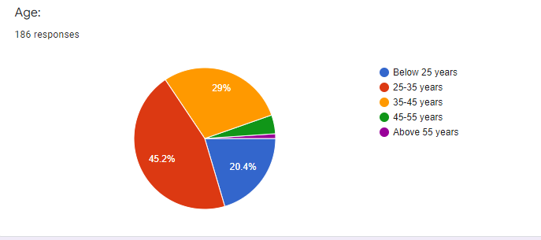

INTERPRETATION:

From the above table and figure it is interpreted that 20.4% of the respondents belongs to Below 25 years, 45.2% of the respondents belongs to 25-35 years, 29% of the respondents belongs to 35-45 years, 4.3% of the respondents belongs to 45-55 years and 1.1% of the respondents belongs to Above 55 years.

Table 4.1.2: Gender wise classification

AGE WISE CLASSIFICATION
S.NO | PARTICULARS | FREQUENCY | PERCENTAGE%
1 | Male | 109 | 58.6%
2 | Female | 77 | 41.4%
3 | Other | 0 | 0%
 | Total | 186 | 100%

Figure 4.1.2: Gender wise classification

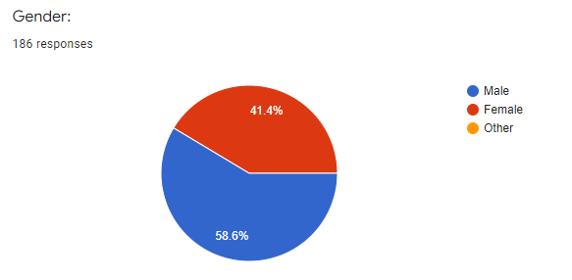

INTERPRETATION:

From the above table and figure it is interpreted that 58.6% of the respondents are male, 41.4% of the respondents are female and No respondents belongs to Other. Most of the respondents are male.

Table 4.1.3: Work Experience classification

WORK EXPERIENCE
S. NO | PARTICULARS | FREQUENCY |  | PERCENTAGE (%)
1 | Less than 5 years | 51 | 27.4%
2 | 5-10 years | 59 | 31.7%
3 | 10-15 years | 46 | 24.7%
4 | 15-20 years | 24 | 12.9%
5 | Above 20 years | 6 | 3.2%
 | Total | 186 | 100%

Figure 4.1.3: Work Experience classification

INTERPRETATION:

From the above table and figure it is interpreted that 27.4% of the respondents belongs to Less than 5 years, 31.7% of the respondents belongs to 5-10 years, 24.7% of the respondents belongs to 10-15 years, 12.9% of the respondents belongs to 15-20 years and 3.2% of the respondents belongs to Above 20 years.

PERCENTAGE ANALYSIS

Table 4.1.4: HR automation of Talent acquisition leads to reduction of manual effort

MS Excel Calculation:

S. NO | PARTICULARS | FREQUENCY | PERCENTAGE (%)
1 | Strongly agree | 97 | 52.2%
2 | Agree | 64 | 34.4%
3 | Neutral | 17 | 9.1%
4 | Disagree | 7 | 3.8%
5 | Highly disagree | 1 | 0.5%
 | Total | 186 | 100%

INTERPRETATION:

From the above table it is interpreted that 52.2% respondents chose Strongly agree, followed by 34.4% respondents chose Agree, followed by 9.1% respondents chose Neutral, followed by 3.8% respondents chose Disagree and finally 0.5% respondents chose Highly disagree as their agreement towards HR automation of Talent acquisition leads to reduction of manual effort.

Figure 4.1.4: HR automation of Talent acquisition leads to reduction of manual effort

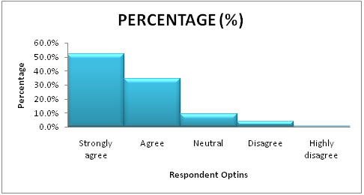

INFERENCE:

From the above figure, it is inferred that high percentage of the respondents has chosen Strongly Agree and Agree as their agreement towards the HR automation of Talent acquisition leads to reduction of manual effort.

PERCENTAGE ANALYSIS

Table 4.1.5: Implementation of RPA as a suitable approach for automating the recruitment and hiring processes

S. NO | PARTICULARS | FREQUENCY | PERCENTAGE (%)
1 | Yes | 128 | 69.2%
2 | No | 15 | 8.1%
3 | Maybe | 42 | 22.7%
 | Total | 185 | 100%

INTERPRETATION:

From the above table it is interpreted that 69.2% of respondents chose ‘Yes’, followed by 8.1% of respondents chose ‘No’ and followed by 22.7% of respondents chose ‘Maybe’ as their agreement towards Implementation of RPA as a suitable approach for automating the recruitment and hiring processes.

Figure 4.1.5: Implementation of RPA as a suitable approach for automating the recruitment and hiring processes.

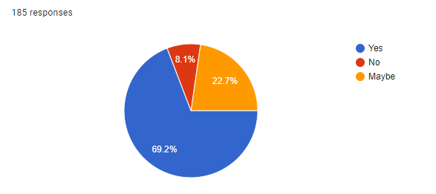

INFERENCE:

From the above figure, it is inferred that high percentage of the respondents has chosen ‘Yes’ as their agreement towards the Implementation of RPA as a suitable approach for automating the recruitment and hiring processes.

CORRELATION ANALYSIS

Table 4.1.6: Proposed technology of RPA has required potential for automating the HR processes and Application of RPA technology in recruitment and selection strategies leads to Employee satisfaction level.

MS Excel Calculation:

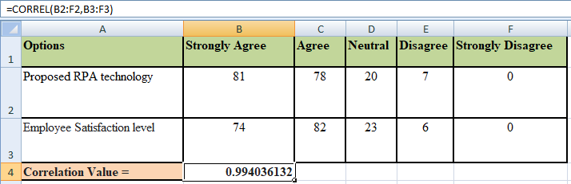

Statistical tool used: Karl-Pearson Correlation.

Reference:
X - Proposed RPA technology.
Y - Employee satisfaction level.

Formula Used: Correlation Coefficient Formula

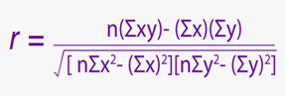
Where,
n = 5
Correlation Value = 0.994036132

Null Hypothesis H₀: There is no significant relation between Proposed RPA technology and Employee Satisfaction level.

Alternate Hypothesis H₁: There is significant relation between Proposed RPA technology and Employee Satisfaction level.

INTERPREATATION:
From the above calculation it is interpreted that, correlation value is = 0.994036132 which is greater than the significance level of α=0.05. So we reject the Alternate Hypothesis and accept the Null Hypothesis which states that there is no significant relationship between these two variables (Proposed RPA technology and Employee Satisfaction level).

CORRELATION ANALYSIS

Table 4.1.7: Better resource allocation can be achieved through automation process and HR personnel’s interaction with the candidates diminishing due to automation process

MS Excel Calculation:

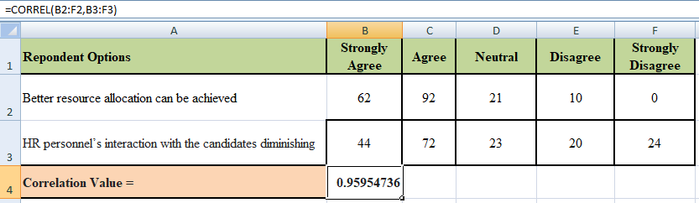

Statistical tool used: Karl-Pearson Correlation.

Reference:
X - Proposed RPA technology.
Y - Employee satisfaction level.

Formula Used: Correlation Coefficient Formula

Where,
n = 5
Correlation Value = 0.95954736

Null Hypothesis H₀: There is no significant relation between Better resource allocation can be achieved and HR personnel’s interaction with the candidates diminishing.

Alternate Hypothesis H₁: There is significant relation between Better resource allocation can be achieved and HR personnel’s interaction with the candidates diminishing.

INTERPREATATION:
From the above calculation it is interpreted that, correlation value is = 0.95954736 which is greater than the significance level of α=0.05. So we reject the Alternate Hypothesis and accept the Null Hypothesis which states that there is no significant relationship between these two variables (Better resource allocation can be achieved and HR personnel’s interaction with the candidates diminishing).

WEIGHTED AVERAGE METHOD

Table 4.1.8 Automation of Talent Acquisition will enhance the performance of HR Professionals involved in HR process

S. No. | Respondent options | Frequency (X) | Weight (W) | XW
1 | Very High | 68 | 0.37 | 25.16
2 | High | 76 | 0.41 | 31.16
3 | Moderate | 33 | 0.17 | 5.61
4 | Low | 6 | 0.03 | 0.18
5 | Fewer | 3 | 0.02 | 0.06
 | TOTAL | 186 | 1 | 62.17

Figure 4.1.8: Automation of Talent Acquisition will enhance the performance of HR Professionals involved in HR process

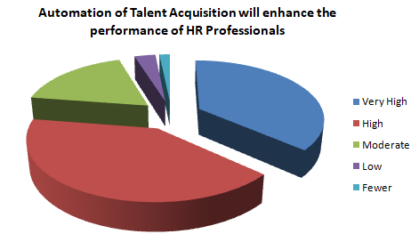

INFERENCE:

Weighted Average = 62.17 ~ 62 approx.

Based on the observations from the weighted average method, it is inferred that High & Very High options are very near to the weighted average value of 62 approx. and can be considered as the acceptance towards automation of talent acquisition enhances the performance of HR Professionals involved in HR process.

Table 4.1.9 Sources of recruitment can be automated to achieve better efficiency on Talent Acquisition process automation

S. No. | Respondent options | Frequency (X) | Weight (W) | XW
1 | Internal Sources | 62 | 0.33 | 20.46
2 | External Sources | 47 | 0.25 | 11.75
3 | Both | 73 | 0.39 | 28.47
4 | None of the above | 4 | 0.02 | 0.08
 | TOTAL | 186 | 1 | 60.76

Figure 4.1.9: Sources of recruitment can be automated to achieve better efficiency on Talent Acquisition process automation

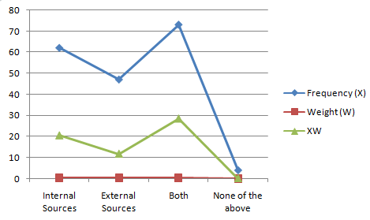

INFERENCE:

Weighted Average = 60.76 ~ 61 approx.

Based on the observations from the weighted average method, it is inferred that the Internal Sources are very near to the weighted average value of 61 approx. and can be considered as the acceptance towards Sources of recruitment can be automated to achieve better efficiency on Talent Acquisition process automation.

.

CHI-SQUARE ANALYSIS

Table 4.1.10: Key drivers for HR process automation on Talent Acquisition module

 | Observed Frequencies
 |  | Work Experience (in years)
Key drivers for HR process automation | Less than 5 years | 5 to 10 years | 10 to 15 years | 15 to 20 years | Above 20 years | Row Total
Reduced time on recruiting and hiring process | 25 | 21 | 12 | 2 | 4 | 64
Increased time for strategic planning | 20 | 24 | 16 | 5 | 3 | 68
Consistent operations globally | 11 | 23 | 18 | 5 | 2 | 59
Streamlined efficient processes | 17 | 19 | 10 | 8 | 5 | 59
All of the above | 21 | 20 | 14 | 14 | 1 | 70
Column Total | 94 | 107 | 70 | 34 | 15 | 320

 | Expected Frequencies
 |  | Work Experience (in years)
Key drivers for HR process automation | Less than 5 years | 5 to 10  years | 10 to 15  years | 15 to 20 years | Above 20 years | Row Total
Reduced time on recruiting and hiring process | 18.80 | 21.40 | 14.00 | 6.80 | 3.00 | 64
Increased time for strategic planning | 19.98 | 22.74 | 14.88 | 7.22 | 3.19 | 68
Consistent operations globally | 17.33 | 19.73 | 12.91 | 6.27 | 2.77 | 59
Streamlined efficient processes | 17.33 | 19.73 | 12.91 | 6.27 | 2.77 | 59
All of the above | 20.56 | 23.41 | 15.31 | 7.44 | 3.28 | 70
Column Total | 94 | 107 | 70 | 34 | 15 | 320

Null Hypothesis (H0): There is no significant dependence between the Key drivers for HR process automation on Talent Acquisition module and Work Experience.

Alternate Hypothesis (H1): There is a significant dependence between the Key drivers for HR process automation on Talent Acquisition module and Work Experience.

 | Observed Frequency (O) | Expected Frequency (E) | O-E | (O-E)^2 | [(O-E)^2]/E
Reduced time on recruiting and hiring process | 25 | 18.80 | 6.2 | 38.44 | 2.04
Reduced time on recruiting and hiring process | 21 | 21.40 | -0.4 | 0.16 | 0.01
Reduced time on recruiting and hiring process | 12 | 14.00 | -2 | 4 | 0.29
Reduced time on recruiting and hiring process | 2 | 6.80 | -4.8 | 23.04 | 3.39
Reduced time on recruiting and hiring process | 4 | 3.00 | 1 | 1 | 0.33
Increased time for strategic planning | 20 | 19.98 | 0.02 | 0.00 | 0
Increased time for strategic planning | 24 | 22.74 | 1.26 | 1.59 | 0.07
Increased time for strategic planning | 16 | 14.88 | 1.12 | 1.25 | 0.09
Increased time for strategic planning | 5 | 7.22 | -2.22 | 4.93 | 0.69
Increased time for strategic planning | 3 | 3.19 | -0.19 | 0.04 | 0.01
Consistent operations globally | 11 | 17.33 | -6.33 | 40.07 | 2.3
Consistent operations globally | 23 | 19.73 | 3.27 | 10.70 | 0.54
Consistent operations globally | 18 | 12.91 | 5.09 | 25.91 | 2.01
Consistent operations globally | 5 | 6.27 | -1.27 | 1.61 | 0.26
Consistent operations globally | 2 | 2.77 | -0.77 | 0.60 | 0.21
Streamlined efficient processes | 17 | 17.33 | -0.33 | 0.11 | 0.01
Streamlined efficient processes | 19 | 19.73 | -0.73 | 0.53 | 0.03
Streamlined efficient processes | 10 | 12.91 | -2.91 | 8.47 | 0.65
Streamlined efficient processes | 8 | 6.27 | 1.73 | 3.00 | 0.48
Streamlined efficient processes | 5 | 2.77 | 2.23 | 4.97 | 1.81
All of the above | 21 | 20.56 | 0.44 | 0.19 | 0.01
All of the above | 20 | 23.41 | -3.41 | 11.63 | 0.50
All of the above | 14 | 15.31 | -1.31 | 1.72 | 0.11
All of the above | 14 | 7.44 | 6.56 | 43.03 | 5.79
 | 1 | 3.28 | -2.28 | 5.19 | 1.59
 |  |  |  | Calculated value | 23.22

Data
Level of significance | 0.05
Number of rows | 5
Number of columns | 5
Degree of freedom (r - 1) * (c - 1) | 16
Results
p-value | 0.108225
Chi-square test calculated value | 23.22
Result: Do not reject the null hypothesis.

INFERENCE:

From the above table 4.4.4, it is inferred that the Chi-Square test calculated value is
23.22 and p-value is less than 5% level of significance on 16 degrees of freedom. Hence, the Null Hypothesis (H0) is accepted. The two variables, Key drivers for HR process automation on Talent Acquisition module and Work Experience are independent to each other.

RANKING METHOD:

Table 4.1.11: Functions of talent acquisition sub processes have the possibility of adopting the HR Automation

MS Excel Calculation:

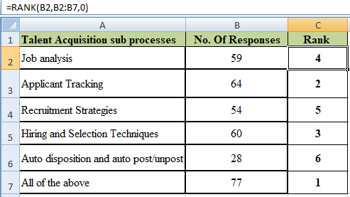

Survey data: Functions of talent acquisition sub processes
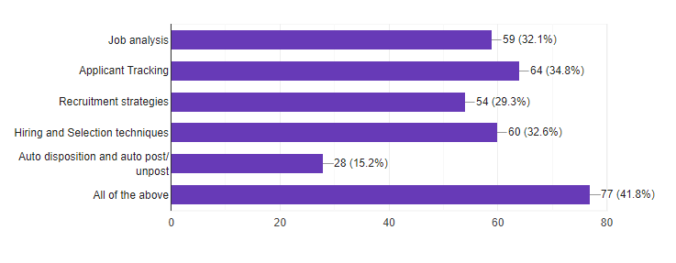

INTERPREATATION:

From the above calculation it is interpreted that, the Talent Acquisition sub processes are considered as the factors for ranking in descending order. In which ‘All of the above’ ranked as ‘1’ and ‘Applicant Tracking’ ranked as ‘2’, ‘Hiring and Selection Techniques’ ranked as ‘3’, ‘Job analysis’ ranked as ‘4’, ‘Recruitment Strategies’ ranked as ‘5’ and ‘Auto disposition and auto post/unpost’ ranked as ‘6’.

RANKING METHOD:

Table 4.1.12: Areas of HR processes may require automation to overcome the future challenges

MS Excel Calculation:

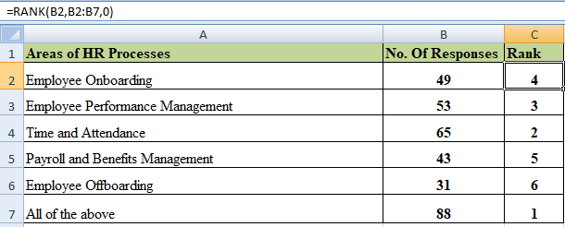

Survey data: Areas of HR processes
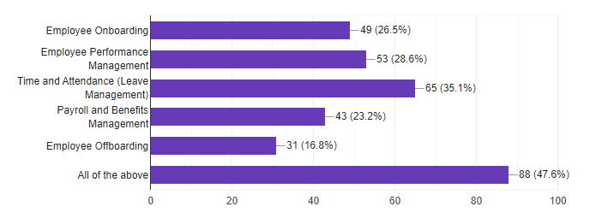
INTERPREATATION:

From the above calculation it is interpreted that, the Areas of HR processes are considered as the factors for ranking in descending order. In which ‘All of the above’ ranked as ‘1’ and ‘Time and Attendance’ ranked as ‘2’, ‘Employee Performance Management’ ranked as ‘3’, ‘Employee Onboarding’ ranked as ‘4’, ‘Payroll and Benefits Management’ ranked as ‘5’ and ‘Employee Offboarding’ ranked as ‘6’.

CHAPTER 5 CONCLUSION

5.1 SUMMARY OF FINDINGS

- The study found the effectiveness of HR Automation process with respect to Talent Acquisition Module in IT companies.

- This study helps us to identify the ongoing HR process and to find the scope of automation of HR activities.

- Based on the survey conducted in various IT organizations, we came to know that the HR automation for Talent Acquisition is much needed by the companies.

- HR automation can streamline the entire functionalities of the recruitment and hiring process.

- HR automation is a key driver to compete in any business and organizations will have dedicated focus towards implementing and managing the automation strategies.

- The application of RPA technology can improve the HR productivity and cost savings by automating manual and repetitive tasks.

- Automation strategy helps to establish a shared vision on streamlining the Talent Acquisition process.

- From the study, we found that the deployment of robotic process automation (RPA) can help to offer better service to employees and managers.

- Automation technology ensures the compliance of HR processes with standards and regulations.

5.2 SUGGESTIONS & RECOMMENDATIONS

- HR Automation strategies needs to be clearly designed based on firm’s business objectives and resource constraints.

- It is important to share the goal and importance of the HR automation of Talent Acquisition system interdepartmentally.

- Organizations should give importance on utilizing the automation technologies in their project works to gain competitive advantage.

- RPA Technology can be utilized after the process flow use cases are formulated in a systematic way.

- The implementation of RPA technology which is rising among IT industries can improve productivity level of HR functions.

- Application of new automation technologies such as Automation Anywhere, UiPath, NICE Systems, Blue Prism, etc., should be appreciated.

- Knowledge Transfer on HR automation process should be given to the employees/HR professionals for performing their job without any blocks.

- Prior training should be given to the professionals for using the RPA technology in order to automate the recruitment and hiring tasks.

- More focus on ‘continuous improvements’ and ‘innovations’ must be appreciated.

- Recognize the effective new approaches within the HR automation of talent acquisition process by institutionalize them.

5.3 CONCLUSIONS

As rising the war for the talent, acquisition of those talent become more important. Hiring managers should act as smart as the competitors in acquiring and retaining talented employees. HR automation helps to acquire manpower in every stage of hiring process. Hiring can become an operational bottleneck that stifles an organization's growth if technology isn't used properly. RPA Technology helps the organization to find the qualified candidates, post job openings in different job boards in less time to get more applications, and reduce the screening time. It automates the whole HR department's recruitment process, giving the recruitment staff and candidates the greatest possible experience. The process of HR Automation plays a significant role in acquiring talented employees and leads to enhance the organization growth and success.

5.4 DIRECTIONS FOR FUTURE RESEARCH

Upon completion of this study, it was found certain areas in which future research can be undertaken. The following recommendations are given for further research keeping in mind the limitations of the present study:

- This study was undertaken purely from an organization‘s perspective of the most effective practices in recruitment and hiring with RPA Technology. However, future research could be undertaken from the perspective of job applicants and their views of which practices are likely to have a positive impact on applicant attraction to the firm.

- The research was focused solely on best practices of Talent Acquisition process automation. However, the competitive labor market conditions, job and organizational attributes, such as compensation, work environment, internal career paths and the type of work etc. can have a major effect on applicant attraction to firms. Hence future research could focus on studying the attributes crucial in attracting the best talent in the industry.

- The future research may focus on the study on effectiveness of automating the other areas of HR Processes such as, Employee Onboarding, Employee performance management, HR Analytics, Leave Management, Payroll and Benefits management and Employee Off boarding.

- Finally, another interesting area for future research would be to study the impact of adopting HR automation process on the organization‘s financial performance and ROI of the company. Future studies should be conducted with bigger sample size, covering more geographies and demographics, also covering more number of IT organizations.

APPENDIX

CENTRE FOR DISTANCE EDUCATION - ANNA UNIVERSITY- CHENNAI CEG STUDY CENTRE

Project Title: A Study on Effectiveness of HR Automation Process with special reference to Talent Acquisition Module across IT companies

Name: Haripriya K J; Roll No: 1926MBA0028; Reg No: 68319200017;

Questionnaire

There are two sections in this questionnaire. Section A contains personal data and section B contains series of questions. While answering section – B, you are kindly requested to express your frank opinion. Your choice is important.

SECTION A:

Name: _____________________________________

Gender: Male
Female
Other

Age: Below 25 yrs
25-35yrs
35-45 yrs
45-55 yrs
Above 55 yrs

Educational
Qualification: Diploma
Graduate
Post Graduate
Other
Company Name (Optional): ____
Designation (Optional): ____
Experience: Less than 5 yrs
5-10 yrs
10-15 yrs
15-20 yrs
Above 20 yrs

SECTION B:

1) Do you think HR automation of Talent acquisition leads to reduction of manual effort in HR operations to a greater extent?
A. Strongly agree
B. Agree
C. Neutral
D. Disagree
E. Strongly disagree

2) Do you think that HR professionals can save time if they utilize the HR process automation in the talent acquisition strategies?
A. Strongly agree
B. Agree
C. Neutral
D. Disagree
E. Strongly disagree

3) Do you agree that the proposed/identified technology of Robotic Process Automation (RPA) has required potential for automating the HR processes/functions?
A. Strongly agree
B. Agree
C. Neutral
D. Disagree
E. Strongly disagree

4) Do you accept the implementation of Robotic Process Automation (RPA) as a suitable approach for automating the recruitment and hiring processes in Talent Acquisition?
A. Yes
B. No
C. Maybe

5) Which of the below sources of recruitment can be automated to achieve a better efficiency on Talent Acquisition process automation?
- Internal sources (Employee Referrals, Transfer, Promotion, Internal Ads, Job Postings on internal company websites etc.)
- External sources (Ads on Management Consultants, Employment agencies,
Employment Exchanges, Recommendations, Posting Social media, etc.)
- Both
- None of the above

6) Do you feel any of the HR processes (Recruitment and Hiring, Employee Onboarding and Offboarding, Employee Performance Management, etc.,) will be affected with further advances in the HR automation technology?
A. Strongly agree
B. Agree
C. Neutral
D. Disagree
E. Strongly disagree

7) Which of the following are considered as the key drivers for HR process automation on Talent Acquisition module in your company?
A. Reduced time on recruitment and hiring process
B. Increased time for strategic planning
C. Consistent operations globally
D. Streamlined efficient processes
E. All of the above

8) According to you, how does the automation of Talent Acquisition will enhance the performance of HR Professionals involved in the HR process?
A. Very Good
B. Good
C. Average
D. Bad
E. Very Bad

9) Is the application of RPA software technology in recruitment and selection strategies leads to Employee satisfaction level?
A. Strongly agree
B. Agree
C. Neutral
D. Disagree
E. Strongly disagree

10) Do you consider the automation of recruitment and hiring makes sense in acquiring a qualified candidate?
A. Strongly agree
B. Agree
C. Neutral
D. Disagree
E. Highly disagree
11) Do you agree with the ideology of implementing HR automation in Talent Acquisition process results into higher productivity?
A. Strongly agree
B. Agree
C. Neutral
D. Disagree
E. Strongly disagree

12) Do you consider better resource allocation can be achieved through automation process in Talent Acquisition strategy?
A. Strongly agree
B. Agree
C. Neutral
D. Disagree
E. Highly disagree

13) Can the HR automation process of Talent Acquisition attract a better qualified candidate who work for the organization effectively & doing things at faster rate?
A. Strongly agree
B. Agree
C. Neutral
D. Disagree
E. Highly disagree

14) Which level of proficiency the HR Personnel should possess on Automation process prior to implement the same in Talent Acquisition strategy?
A. Very High
B. High
C. Moderate
D. Low
E. Fewer

15) Is the HR personnel’s interaction with the candidates in assessing their attitude towards the job, work ethics, and willingness, diminishing due to automation process?
A. Strongly agree
B. Agree
C. Neutral
D. Disagree
E. Highly disagree

16) Which of the following functions of talent acquisition sub processes have the possibility of adopting the HR Automation?
A. Job analysis
B. Applicant Tracking
C. Recruitment strategies
D. Hiring and Selection techniques
E. Auto disposition and Auto post/unpost
F. All of the above
17) Do you think security of data is assured in HR automation process?
A. Strongly agree
B. Agree
C. Neutral
D. Disagree
E. Highly disagree

18) Do you agree that the HR automation process is redefining the HR role to drive efficiency of future work?
A. Strongly agree
B. Agree
C. Neutral
D. Disagree
E. Strongly disagree

19) Do you think the functionality of an HR automation process make it suitable to streamline the Talent Acquisition framework?
A. Strongly agree
B. Agree
C. Neutral
D. Disagree
E. Highly disagree

20) Do you agree the HR Automation process would provide a better ROI to your company?
A. Strongly agree
B. Agree
C. Neutral
D. Disagree
E. Highly disagree

21) According to you, which areas of other HR Processes require automation to overcome the future challenges?
A. Employee Onboarding

B. Employee performance management

D. Time and Attendance (Subset: Leave Management)

E. Payroll and Benefits management

F. Employee Off boarding

G. All of the above

BIBLIOGRAPHY

- Kumar R. (2011). Research Methodology – A Step-by-Step Guide for Beginners. Sage.

- S.N. Murthy and U.Bhojanna. (2010). Business Research Methods. Excel Books.

- Kothari, C.R. (2008). Research Methodology: Methods and Techniques. New Age International.

- D.P.Apte, Statistical Tools for Managers, Excel Books.; Delhi, 2009.

- RS Bhardwaj, Mathematics and Statistics for Business, Excel Books, First Edition New Delhi, 2013.

REFERENCES

Yamini Meduri and Pavithra Yadav; “AUTOMATION INVADING HUMAN RESOURCES DIGITAL TRANSFORMATION AND IMPACT OF AUTOMATION IN THE SPACE OF HR”, Delhi Business Review Ξ Vol. 22, No. 1 (January - June 2021).

- Sathiyaseelan Balasundaram and Sirish Venkatagiri; “A structured approach to implementing Robotic Process Automation in HR”, Journal of Physics: Conference Series, 1427 (2020) 012008 doi:10.1088/1742-6596/1427/1/012008

- Mishra, Shubham; Kunte, Monica; Neelam, Netra; Bhattacharya, Sanjay and mulay, preeti; "HR Process Automation: A Bibliometric Analysis" (2021), Library Philosophy and Practice (e-journal). 5577.

- Dr.M. Nishad Nawaz and Dr.Anjali Mary Gomes; “Automation of the HR functions enhance the professional efficiency of the HR Professionals-A Review”, International Journal of Management, IT and Engineering, IJMIE, Volume 4, Issue 2; ISSN:2249-0558, February 2014.

- Richard D. Johnson, Dianna L. Stone and Kimberly M. Lukaszewski; “The benefits of eHRM and AI for talent acquisition”, JOURNAL OF TOURISM FUTURES, VOL. 7 NO. 1 2021, pp. 40-52, Emerald Publishing Limited, ISSN 2055-5911, DOI 10.1108/JTF-02-2020-0013.

- Dr Nishad Nawaz; “ROBOTIC PROCESS AUTOMATION FOR RECRUITMENT PROCESS”, International Journal of Advanced Research in Engineering and Technology (IJARET), Volume 10, Issue 2, March-April 2019, pp. 608-611. Article ID: IJARET_10_02_057, ISSN Print: 0976-6480 and ISSN Online: 0976-6499.

- Dr. Aruna Deshpande; “Talent Acquisition through Technology”, ADMIFMS International Management Research Conference 2018, IOSR Journal of Business and Management (IOSR-JBM), e-ISSN: 2278-487X, p-ISSN: 2319-7668.

- Dr. Debashish Sengupta, Prof. Ray Titus and Subhashish Sengupta; “Transition to an Automated Online Talent Acquisition System in an IT Project-Based Organization: A Case Study”, PM World Journal, Vol. IV, Issue XII – December 2015.

- Bajeesh Balakrishnan and Dr. R Duraipandian; “Automation of HR practices using E-HRM controllers in IT Organizations” International Journal of Control and Automation – Vol. 13, No. 2s, (2020), pp. 292-300.

Reference Links:

https://www.proquest.com/scholarly-journals/structured-approach-implementing-robotic-process/

https://www.researchgate.net/publication/349190203

https://digitalcommons.unl.edu/libphilprac/5577/

https://www.researchgate.net/publication/271132327

https://www.researchgate.net/publication/342942673_

http://sersc.org/journals/index.php/IJCA/article/view/11829

https://www.iosrjournals.org/iosr-jbm/papers/Conf.ADMIFMS1808-2018

http://iaeme.com/Home/issue/IJARET?Volume=10&Issue=2

https://pmworldlibrary.net/wp-content/uploads/2015/

